February 2024

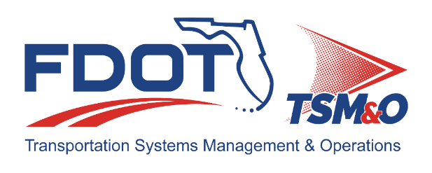

Florida ITS Architecture Support and Maintenance Project
Final Florida Turnpike Enterprise (FTE) Update Report
Version 1.0

Document Version Control
Author / Action | Submittal Date | Version No.
David Binkley / Draft Document | November 29, 2023 | 1.0
Cliff Heise / QA/QC Review | November 29, 2023 | 1.0
David Binkley / Finalized document | February 9, 2024 | 1.0

Table of Contents
1.0 Introduction 4
2.0 Description of Changes 4

List of Tables
Table 1 ARCHITECTURE Updates 5
Table 2 Architecture Maintenance Log (FTE RITSA) 7

Introduction
This Update Report for the Florida Turnpike Enterprise (FTE) Regional ITS Architecture (RITSA) identifies the revisions incorporated into the architecture. The purpose of this FTE RITSA Update Report is to document revisions made to the FTE RITSA to support Stakeholder input received through Architecture Change Requests as part of the Florida Intelligent Transportation Systems (ITS) Architecture Support and Maintenance Project.
The Florida ITS Architecture Support and Maintenance Project included the initial major update of the Statewide ITS Architecture (SITSA) and seven RITSAs. Following the major update phase, periodic updates are executed to maintain the architecture content. The FDOT Architecture Team coordinates with the FDOT Project Manager or designee and each applicable District Transportation Systems Management and Operations (TSM&O) Program Engineer or designee for the RITSAs.

Description of Changes
One maintenance log items was addressed in the update. Table 1 provides descriptions for each change request that was implemented in the architecture update. A log reference number is provided for each change to related it to the Architecture Maintenance Log that is provided in Appendix A. Each architecture change that is received is added to the maintenance log for tracking and disposition.
Information about stakeholders, elements, and services is provided to summarize the changes. Some architecture components such as interfaces, roles and responsibilities, functional requirements and standards are numerous and can be reviewed on the architecture website or in the Regional Architecture Development for Intelligent Transportation (RAD-IT) software tool to explore the details of each project.

Table 1 ARCHITECTURE Updates
Change | Log Ref # | Actions Taken / Changes Implemented
Rename stakeholder from Miami-Dade Expressway Authority (MDX) to the Greater Miami Expressway (GMX) Agency. | 183 | Renamed the stakeholder in the stakeholder listing as well as inventory elements that included MDX in the title or description. Also update agreements and service package instances that included references to MDX.

Appendix A: Architecture Maintenance Log (District 4/6 RITSA)
The maintenance log in Table 2 provides the District 4/6 RITSA maintenance items considerations for the update.

Table 2 Architecture Maintenance Log (FTE RITSA)
# | Date | Architecture | Source | Contact | Change | Disposition | Recommend Maintenance | Incorporated
183 | 10/19/2023 | FTE RITSA | Email Request | Christine Shafik, State TSMO | Rename stakeholder from Miami-Dade Expressway Authority (MDX) to the Greater Miami Expressway (GMX) Agency. | Update Stakeholder name in names and descriptions. | Yes | Yes

